Adithya.J

230701013 CSE A

EXP NO:5 System Calls Programming

PROGRAM

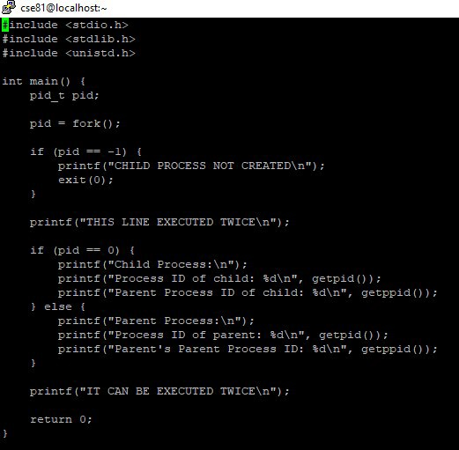

OUTPUT

